**Computer Games Development Programming Assignment**

**Name:** Kristina Fernandes (D12125586)

**Theme**: A SHORT DOCUMENTARY ON THE LIFE OF BIRDS

**Time Duration**: 2 mins

**Scenario** : My documentary is set on an island with tall trees and mountains over which the birds would fly and pursue spiders.

**Story**: There will also be text displayed on the scene during the various scenes describing what the birds are doing and giving vaious facts about the life of birds.

**Music**: There will also be ambient music and several ‘nature sounds’ to help bring the documentary to life.

**Scene 1**: BIRDS FLYING IN THE AIR

I would be inplementing several steering behaviours to simulate the behaviour of birds e.g. flocking, seperation , cohesion and and alignment .etc

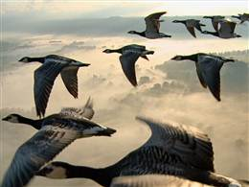

My Island scene has already been created in unity. I have also imported my bird models, which I intend to; add textures to and possibly animation.

**Scene 2:** BIRD HUNTING SPIDER PREY

I intend to implement steering behaviours such as pursue, seek and flee to simulate the way birds prey on spiders for food. The spider should flee when a bird comes within a certain range.

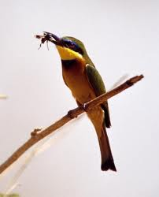

The spider models have also been imported into my unity project as well; I will be editing it and adding a few more textures to it.

Each scene should be about a minute long.